Multiple choice section

|  |  |  |  |  |  |  |  |  |  |  |
| --- | --- | --- | --- | --- | --- | --- | --- | --- | --- | --- |
| Question | 1 | 2 | 3 | 4 | 5 | 6 | 7 | 8 | 9 | 10 |
| Answer | C | A | A | B | A | A | C | C | B | B |

Question 1 [1.1]

C

12 –  = -4

- = -16

-8x = -48

x = 6

Question 2 [1.1]

A

7(a – 2) = 2(2a – 1)

7a – 14 = 4a – 2

3a = 12

a = 4

Question 3 [1.2]

A

8x – 4y = 12

8x – 12 = 4y

y = 2x – 3

gradient = 2

Question 4 [1.2]

B

Lines parallel to the x-axis (horizontal lines) have a gradient of zero.

Question 5 [1.3]

A

y = -x + 4

5y = -3x + 20

3x + 5y = 20

Question 6 [1.4]

A

The line with equation y = -x – 2 has the gradient of -.

The line with equation x + 2y = -2 or y = -x – 1, has the same gradient -. These lines are parallel.

Question 7 [1.4]

C

The line with equation y = -2x – 3 has a gradient of -2. A line which is perpendicular to this line has a gradient of  as -2 ×  = -1.

Question 8 [1.5]

C



Question 9 [1.5]

B

 < 2

4 – 6x < 18

-6x < 14

x > -2.3333...

So x = -2.7 is not a solution.

Question 10 [1.6]

B

Substitute y = -3x + 5 into   
3y + 2x = -6:

3(-3x + 5) + 2x = -6

-7x + 15 = -6

-7x = -21

x = 3

Substitute x = 3 into y = -3x + 5:

y = -3 × 3 + 5 = -4

x = 3, y = -4

Multiple-choice total marks: 10

Short answer section

Question 11 11 marks

(a) The general equation of a straight line is y = mx + b where m is the gradient of the line and b is the *y-intercept* of the line.

(b) A *linear relationship* exists between two variables when the graph of the relationship is a straight line.

(c) A linear relationship is described by a *linear equation*.

(d) Linear equations can be solved by applying *inverse operations* to both sides of the equation.

(e) The *gradient* of a line is a measure of its steepness, which can be evaluated by evaluating the fraction *rise over run*.

(f) Lines that are *parallel* have the same gradients.

(g) Lines that are *perpendicular* meet each other at an angle of 90°.

(h) A linear equation has *one* solution and a linear *inequality* has a range of solutions according to the inequality.

Question 12 4 marks [1.3, 1.4]

Answers may vary.

Lines that are parallel to the line  have a gradient of 1 and lines that are perpendicular to that line have a gradient of -1. The equations and graphs of the lines need to have these gradients and intercept the y-axis at the position consistent with each equation.

Question 13 3 marks [1.1]

  
7x – 2 = 40

7x = 42

x = 6

Question 14 4 marks [1.1]

  
5(3x + 1) + 4(2x + 3) = 40, 15x + 5 + 8x + 12 = 40

23x + 17 = 40

23x = 23

x = 1

Question 15 2 marks [1.2]



Question 16 2 marks [1.3]

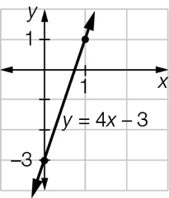

Question 17 4 marks [1.4]

(a) The lines  or and  have the same gradient so are parallel.

(b) The line with equation  or  has a gradient of . The line with equation has a gradient of -3. The product of the gradients is -1 so they are perpendicular.

Question 18 4 marks [1.5]

(a) 4x – 3 ≤ 17  
4x ≤ 20  
x ≤ 5

(b) 6x – 2 > 10  
6x > 12  
x > 2

Question 19 4 marks [1.6]

x = 2y + 4

2y – 4x = 2

2y – 4(2y + 4) = 2

-6y – 16 = 2

6y = -18

y = -3

x = 2(-3) + 4 = -2

Solution: (-2, -3)

Question 20 4 marks [1.6]

3x – 4y = 13

5x + 3y = 12

9x – 12y = 39

20x + 12y = 48

29x = 87, so x = 3

Hence y = -1

Solution: (3, -1)

Question 21 3 marks [1.1]





4x – 2 = 4 × 6 – 2 = 22

The dimensions are: two sides of 1 cm and one side of 22 cm.  
These lengths are not possible for a real triangle.

Short answer total:_________/45

Extended answer section

Question 22 6 marks [1.2, 1.3, 1.4]

(a) 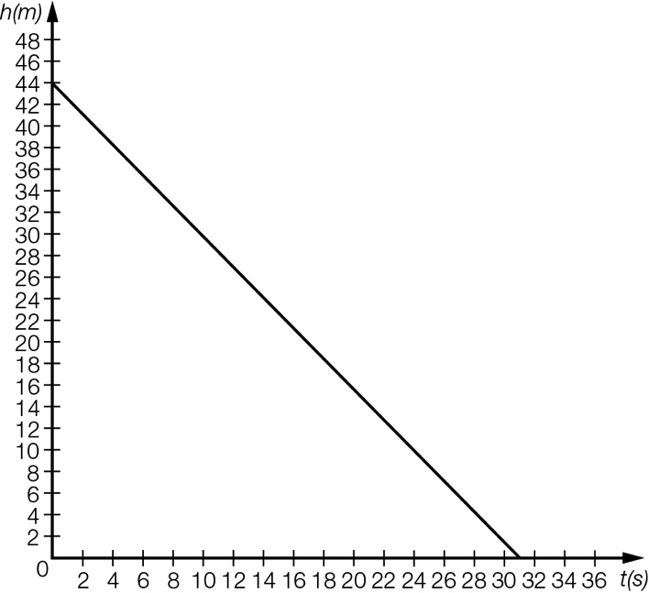

(b) Gradient = , hence rate of descent is 

(c) 

(d) The elevator is 44 m high.

Question 23 10 marks [1.2, 1.3, 1.4]

(a), (b) (i), (c) (i) 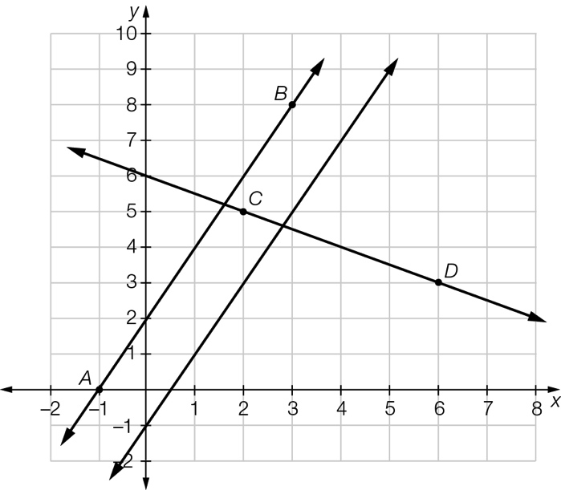

(b) (i) Equation of the line AB is 

(ii) As the gradient of both lines is 2 then they are parallel.

(c) (i) Equation of the line CD is 

(ii) As the product of the gradient of the lines is -1  then they are perpendicular.

Question 24 4 marks [1.6]

(a)  where b is the number of buns.

(b)



The baker can make up to 400 more buns.

Question 25 5 marks [1.5]

4a + 2b = 100 [1]

2a + 6b = 150 [2]

2a + b = 50 [1] ÷ 2

Subtract: [2]– [1] ÷ 2

5b = 100, so b = 20, hence a = 15

Each apple cost 15 cents and each banana cost 20 cents.

Extended answer total:______/25

TOTAL test results: _____ / 80